Re: Overview of T1-based automated brain segmentation pipeline
by Susumu Mori, 6/19/2016

Dear MriCloud users,
As our automated pipelines become matured, we see more users start testing them. I found that this is a time for us to explain the T1-based image segmentation pipeline in detail so that users can understand how to use it and, more importantly, avoid potential errors or bias in the results. I used a bold font for most important messages in this document and please go over and understand them. First of all, we will resume monthly 2-day tutorial from August, 2016. We recommend to attend these tutorials to learn how to properly use our tools posted in www.mricloud.org, which include automated analysis tools for T1, DTI, fs-fMRI, and ASL. If you are interested in the tutorial, please contact Xin Li (xli16@jhmi.edu). We accept up to 12 people in one tutorial session.

1: Our T1-based segmentation pipeline assumes that you are submitting MPRAGE data with less than 1.2 mm resolution.
Many of our current atlases follow ADNI protocols. We, therefore, recommend to use the ADNI-MPRAGE protocol.
2: Our T1-based segmentation is based on multiple atlases;
The number of atlases varies from 10 to over 30 depending on the age range. As of 6/10/2016, atlases that cover four different age groups are posted in MriCloud. These atlases are receiving frequent updates and the latest version is V. 9.a. These atlases contain more than 280 defined structures and we are doing our best to make the segmentation as accurate as possible. Currently, the segmentation accuracy of most of the internal structures are high, but the refinement of the fine cortical parcellation is still work in progress. This is also related to the 4th point below and please read it carefully. In the atlas list, we keep some old versions to support legacy studies. You can find release notes in www.mricloud.org. In general, when there is a large change in the number of defined structures, a different version number is assigned, while refinement of the segmentation quality leads to a sub-version such as a, b, c. Some version of the atlases can be downloaded from “Atlas Repository” in www.mricloud.org. We are doing our best effort to refine the quality of the atlas libraries and any report about errors would be highly appreciated.
3: Our pipeline offers hierarchical segmentation;
Depending on the versions of the atlas, the number of the segmented structures vary, but typically there are 280-300 structures. The output files contains the volumes of all these structures. Also, we offer hierarchical structural definitions by creating superstructures by combining these 280-300 structures based on their anatomical definitions. Fig. 1 is from D. Wu, et al, (Neuroimage, 2016, 125, 120-130), explaining the concept of the hierarchical definition.
Fig. 1: Five-level hierarchical definitions of the brain. For example, in Level 1, only eight structures are defined (only five are shown but some of them have right and left). One of them is the telencephalon, which is divided into cortex, deep gray nuclei, and white matter in Level 2.

Also, we are offering two types of the hierarchical definitions, Type I and II, as shown in Fig. 2. Type I follows classic ontological relationship while the Type II follows the definitions of the brain structures more widely used in Radiology and Neurological studies. For example, the telencephalon and diencephalon are divided in the highest level (Level 1) in Type I but they are combined as “Hemisphere” in Type II. In Type I, the gray matter and white matter are separated in early level (Level 2), while, in Type II, lobes were separated before the gray and white matter structures are separated. Therefore, the same “frontal lobe” in Type I contains only frontal lobe cortex, while that of Type II contains both cortex and the associated (peripheral) white matter structures in the frontal lobe. By combining all superstructures defined in Type I and II, more than 500 unique structural entities are defined in our pipeline. Please note that the same anatomical name (e.g. hippocampus) in not only different “Types” but also different “Levels” may have different anatomical definitions (e.g. hippocampus in Level 4 is the combination of Level-5-fimbria and Level-5-hippocampus). Therefore, for accurate communication, anatomical names need to be accompanied by the Type and Level information.

Fig. 2: Comparison of Type I and Type II hierarchical definitions of superstructures.

4: Interpretation of the segmentation results needs caution
There are two reasons why we are offering this hierarchical system. First, we can test regional specificity of pathology. For example, even if you find the hippocampus has 10% atrophy in a dementia population, this report could be misleading if the entire limbic system, or the entire hemisphere, has 10% atrophy. With this hierarchical system, you can test the regional specificity of the finding. Second, the definitions of larger structures are more reliable. This is due to several reasons; size, lack of contrasts, and lack of anatomical clues.
Size: The signal-to-noise has higher impacts on the definition of smaller structures. Fig. 3 is from A. Djamanikova et al, (Neuroimage, 2014, 101, 168-176), showing the relationship between the test-retest reproducibility and the size of the defined structures. It shows poor reproducibility (>5%) for those structures much smaller than 1 ml (1,000 voxels).

Fig. 3: Relationship between measurement precision and the size of the anatomical units.

Segmentability (lack of contrasts and anatomical clues): Another important factor is the “segmentatbility” of the structures at the finest level (Level 5) with more than 280 structures; not all structures share the same level of the segmentability. Poor segmentability is mainly due to lack of contrasts or lack of anatomical clues. When we are using T1-weighted contrasts, many white matter structures defined at Level 5 fall into the “lack of contrast” category. Fig. 4 shows examples in the brainstem, in which many internal white matter structures are defined in the Level 5 segmentation, but are not visible in T1. Our atlases were historically developed by integrating T1, T2, and DTI. Therefore, with only T1-weighted images, there are certain structures that are not visible and, thus, not reliably segmented. Therefore, the segmentation results are only approximation. Certain gray matter structures such as the substantia nigra and the red nuclei also fall in this category. We are keeping these T1-invisible labels for the future applications where T1, T2, DTI may be combined for better segmentation accuracy, but when we are using single-contrast image segmentation, there are labels that may not be well visible in a given MR contrast. We, therefore, need to know how to interpret the results. Examples of “lack of anatomical clues” are fine cortical pacellations. For example, the frontal lobe is divided into various finer parcels such as superior frontal, middle frontal, inferior frontal, etc in Level 5. The boundaries of these parcels often lack clear anatomical clues and our atlases offer only approximation. In addition, as mentioned in Section #2, the quality of fine cortical parcels are still work in progress.

Fig. 4: Example of the lack of contrast in T1-weighted images to accurately define fine white matter structures.

In Table 1, structures in each level that require careful examination of the quantification results are indicated by red color. For these structures indicated by the red color, we recommend to use higher-level segmentation (Level 3-4, indicated by a blue color) for quantification purpose (Fig. 5). If you have hypothesis-driven studies that focus on specific cortical areas, such as the entorhinal cortex, the automated segmentation at Level 5 could be used as an initial template, followed by manual delineation.
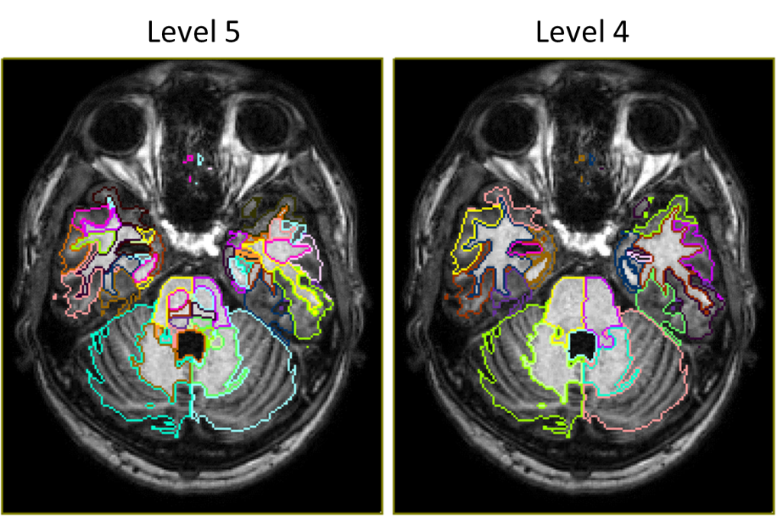
Fig. 5: When T1-weighted images are used for the brain segmentation, Level 4 is more appropriate to examine the pons anatomy rather than the anatomy of various white matter structures within the pons defined in Level 5 due to the lack of contrasts.

Table 1: List of defined structures in Version 9.a. Those indicated by red need to be interpreted with caution.

